271 Windows set up React Native

1. Java sdk needed for adroid apps of any type – DL the latest version 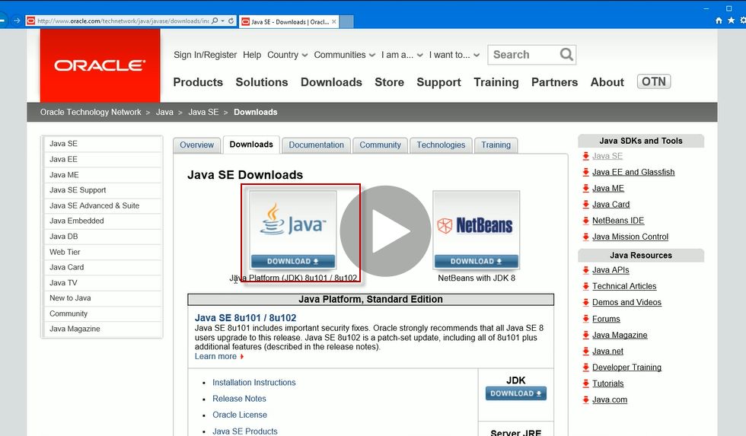

Agree and accept lic agreement, then windows 64

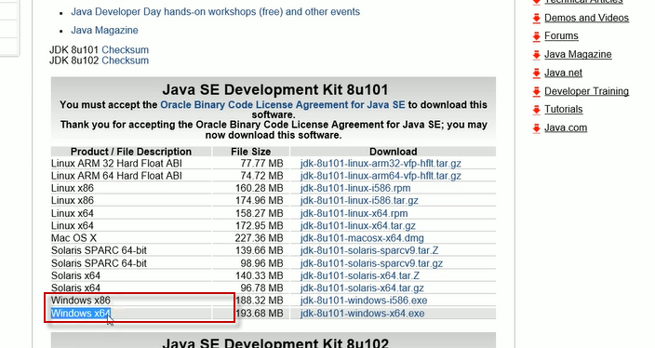

After DL install, take defaults

1. Install Node JS - already have this
2. Python 2 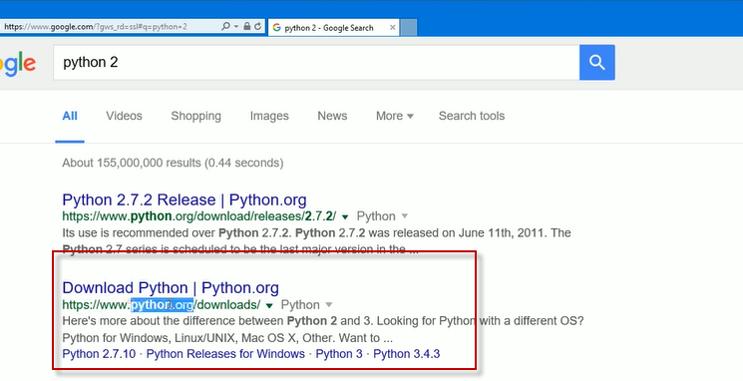

Pick version 2

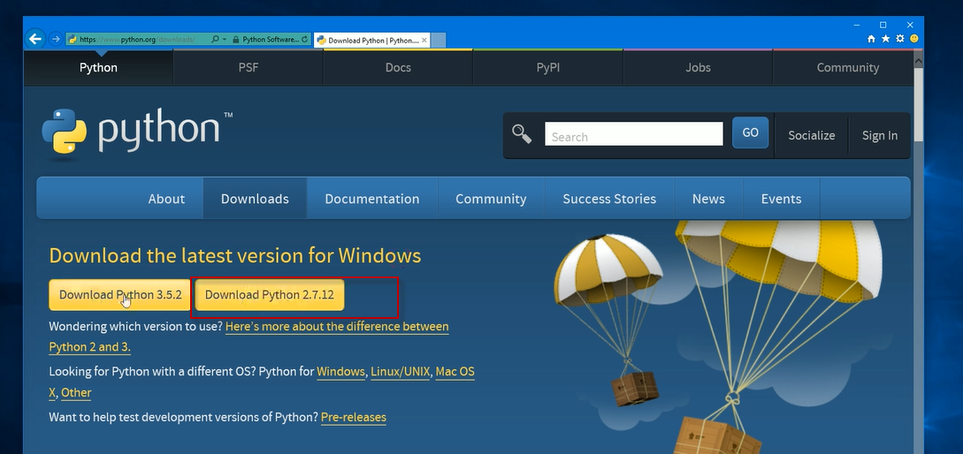

4)Download Android Studio

